# VISVESVARAYA TECHNOLOGICAL UNIVERSITY

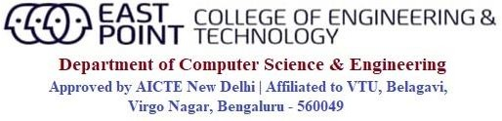

Jnana Sangama, Belagavi-590018

**An Internship (21INT49) Report on**

**“Hotel Billing System”**

***Submitted in partial fulfillment of the requirements for the award of degree of***

## BACHELOR OF ENGINEERING IN

**COMPUTER SCIENCE AND ENGINEERING**

## By

**PRITISH ALI (1EP21CS076)**

|  |  |
| --- | --- |
| **Internal Guide:**  **Prof. Manimegalai Asst. Professor,**  **Dept. of CSE, EPCET** | **Company Guide:**  **Himanshu Khatri**  **Software Engineer,**  **NARAYANA** |

**2022-2023**



**CERTIFICATE**

This is to certify that the Internship (21INT49) entitled “Java Development” is a bonafide work carried out by **Pritish Ali [1EP21CS076]**, in partial fulfillment of the requirements of BACHELOR OF ENGINEERING in COMPUTER SCIENCE AND ENGINEERING in VISVESVARAYA TECHNOLOGICAL UNIVERSITY, Belgaum, during the year 2022-2023. It is certified that corrections/suggestions recommended have been incorporated in the Internship report.

|  |  |  |  |  |  |  |  |
| --- | --- | --- | --- | --- | --- | --- | --- |
| **Internal Guide** | **Company Guide** | **Signature of HOD** | **Signature of Principal** |  |  |  |  |
| **Prof. Manimegalai** | **Himanshu Khatri** | **Dr. I Manimozhi** | **Dr. Mrityunjaya V Latte** |  |  |  |  |
| **Asst. Professor,** | **Software Engineer,** | **HOD, Dept. of CSE,** | **Principal,** |  |  |  |  |
| **Dept. of CSE, EPCET,**  **Bangalore.** | **NARAYANA** | **EPCET, Bangalore** | **EPCET, Bangalore** |  |  |  |  |

### Reviewers:

**Reviewer Panel Member**

### Name:Prof. Divya U H Name: Dr. I Manimozhi

**Signature with date: Signature with date:**

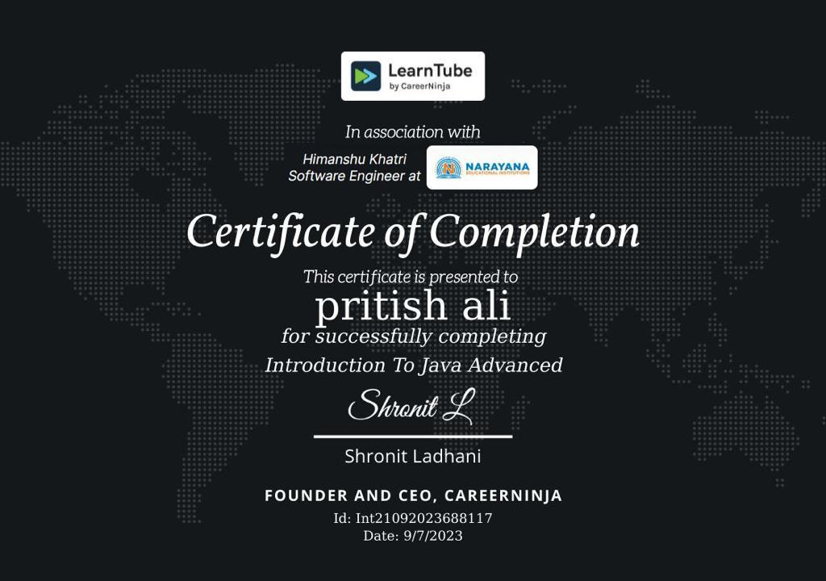

# ACKNOWLEDGEMENT

First and foremost, I would like to express my sincere regards and thanks to **Management** of **East Point Group of Institutions, Bengaluru** for providing me an opportunity to work on this Internship.

I am ineffably indebted to **Dr. S Prakash, Senior Vice President**, **East Point Group of Institutions,** for his conscientious guidance and encouragement to accomplish this Internship.

I would like to express my humble and sincere thanks to **Dr. Mrityunjaya V Latte, Principal, East Point College of Engineering and Technology** for his suggestions that motivated me for the successful completion of my Internship.

I would like to express my heartfelt thanks to **Dr. I Manimozhi**, **Professor and Head of Department** of Computer Science and Engineering, EPCET for her valuable advice and suggestions to do my best in this Internship.

I am obliged to guide **Prof. Manimegalai**, Asst. Professor, Dept. of CSE, Internship Coordinators **Prof. Madhushree**, Assistant Professor, Dept. of CSE and **Prof. Nithyananda C R,** Associate Professor, Dept. of CSE who have rendered valuable assistance and guidance for the Internship.

I would like to thank **Mr.** **Himanshu Khatri** , Software Engineer, NARAYANA for providing with technical support and knowledge.

I would like to thank my **Parents** and **Friends** for their support and encouragement during the course of my Internship. Finally, I offer my regards to all the **Faculty members of the CSE Department** and all those who supported me in any respect during the Internship.

**Pritish Ali [ 1EP21CS076 ]**

**i**

# CONTENTS

**Chapter no. Description Page no.**

1. Company Profile 1
2. About Company 2
3. Task Performed 3
   1. Introduction to JAVA 4
      1. Features of JAVA 4
      2. Applications of JAVA 5
      3. Advantages of JAVA 5

3.1.4 Disadvantages of JAVA 6

* 1. Introduction to Java Servlets 7
     1. Features of Java Servlets 7
     2. Applications of Java Servlets 7
     3. Advantages of Java Servlets 7
     4. Disadvantages of Java Servlets 7
  2. Introduction to Git and GitHub 8
     1. What is Git ? 8
     2. What is GitHub ? 8
     3. Applications of GitHub 8
     4. Advantages of GitHub 9
     5. Disadvantages of GitHub 9

1. Reflection 10
   1. Implementation of the Project 10
   2. Output 17
2. Conclusion 20

References 21

|  |  |  |
| --- | --- | --- |
|  | **List of Figures** |  |
| **Fig. no.** | **Description** | **Page no.** |
| 4.2.1 | Adding Food Item By The Owner | 15 |
| 4.2.2 | Displaying Menu And Order Food Item | 16 |
| 4.2.3 | Generating Bill Including GST | 17 |
|  |  |  |

**iv**

**CHAPTER 1**

**COMPANY PROFILE**

**Introduction**

LearnTube.ai is an innovative and cutting-edge technology company that specializes in creating advanced artificial intelligence-powered learning solutions. Established in 2016, the company's mission is to revolutionize education and training by leveraging the potential of AI to make learning more personalized, interactive, and accessible to learners of all ages and backgrounds. LearnTube.ai is committed to building a brighter future where everyone can acquire knowledge efficiently and effectively.

**Vision and Mission**

LearnTube.ai envisions a world where learning is not confined to traditional classrooms but is accessible to all, irrespective of geographical barriers or financial constraints. Their mission is to harness the power of AI and machine learning to create adaptive learning platforms that cater to individual learning styles, preferences, and pace. They aim to empower educators and learners alike with innovative tools and solutions, fostering a lifelong passion for learning.

**Key Services**

AI-Powered Learning Platforms: LearnTube.ai develops state-of-the-art learning platforms that utilize AI algorithms to analyze learner behaviors and preferences. This data-driven approach allows the platform to deliver personalized content and recommendations, ensuring a more engaging and effective learning experience.

Content Creation and Curation: The company also excels in content creation and curation, providing high-quality educational materials, including video lessons, interactive quizzes, and simulations. Their content is tailored to meet the specific requirements of different courses and subjects, making learning more enjoyable and effective.

**CHAPTER 2**

**ABOUT COMPANY**

**Virtual Reality (VR) Learning**

Recognizing the immense potential of VR in education, LearnTube.ai has integrated virtual reality into their learning platforms. VR-based experiences enable learners to immerse themselves in realistic and interactive environments, enhancing their understanding and retention of complex concepts.

**Data Analytics and Insights**

LearnTube.ai emphasizes data-driven decision-making, leveraging advanced analytics to track learner progress, identify knowledge gaps, and refine their learning models. This data-centric approach allows educators to assess the effectiveness of their teaching methods and make necessary adjustments for better outcomes.

**Advantages and Innovations**

Personalized Learning Experience: By harnessing AI, LearnTube.ai provides learners with personalized learning paths, taking into account their strengths, weaknesses, and learning preferences. This adaptability fosters a deeper understanding of the material and promotes self-directed learning.

**Engaging and Interactive Content**

LearnTube.ai's content is designed to be interactive, visually appealing, and engaging. This approach keeps learners motivated, leading to improved knowledge retention and overall learning outcomes.

**Continuous Improvement**

LearnTube.ai places a strong emphasis on research and development. They continuously refine their AI algorithms and learning models based on user feedback and emerging trends in the educational technology space, ensuring that their products remain at the forefront of innovation.

# CHAPTER 3

**TASK PERFORMED**

During this internship, a Hotel Billing System was developed using Java, which aimed to implement a billing system benefiting both the owner and the customer. The owner had the ability to configure the menu, set prices, and make updates as necessary. Additionally, the system enabled the owner to manage customer orders, display the menu, and generate bills.

Throughout this internship, proficiency was gained in Java, servlets, and the JDK (Java Development Kit). Servlets, as an integral part of Java-based web applications, were learned, along with the JDK's importance in Java application development. Active participation in GitHub libraries was also undertaken, contributing to collaborative coding efforts and skill improvement, while providing a platform to showcase the work.

The internship provided the opportunity to tackle an existing problem, addressing the common issue of slow and error-prone typing. This experience equipped me with the skills required to utilize programming languages in solving real-world issues. Various tasks were completed during this period, with challenges encountered along the way, which served as valuable learning experiences.

# ADVANTAGES AND CHALLENGES WHILE COMPLETING THE PROJECT

**Advantages includes –**

* Team Work
* Flexibility
* Developed a thorough knowledge about the topic
* Learnt about different libraries
* Time Management
* Learnt a proper use of virtual platform
* Contributed to GitHub libraries

**The challenges include –**

* Java Code level issues
* Out-of-Memory Errors
* Tried merging the Java code into .jsp but failed to do so
* Issues in creating mathematical formula for testing accuracy
* Problem in comparing the sentences word by word
* Logical Error

## Introduction to JAVA

Java is a **programming language** and a **platform**. Java is a high level, robust, object-oriented and secure programming language.

Java was developed by Sun Microsystems (which is now the subsidiary of Oracle) in the year 1995. James Gosling is known as the father of Java. Before Java, its name was Oak. Since Oak was already a registered company, so James Gosling and his team changed the name from Oak to Java.

**Platform**: Any hardware or software environment in which a program runs, is known as a platform. Since Java has a runtime environment (JRE) and API, it is called a platform.

### Features of Java

* Java works on different platforms (Windows, Mac, Linux, Raspberry Pi, etc.)
* It is one of the most popular programming language in the world
* It has a large demand in the current job market
* It is easy to learn and simple to use
* It is open-source and free
* It is secure, fast and powerful
* It has a huge community support (tens of millions of developers)
* Java is an object oriented language which gives a clear structure to programs and allows code to be reused, lowering development costs
* As Java is close to [C++](https://www.w3schools.com/cpp/default.asp) and [C#](https://www.w3schools.com/cs/default.asp), it makes it easy for programmers to switch to Java or vice versa

### Applications of Java

According to Sun, 3 billion devices run Java. There are many devices where Java is currently used. Some of them are as follows:

* Desktop Applications such as acrobat reader, media player, antivirus, etc.
* Web Applications such as irctc.co.in, javatpoint.com, etc.
* Enterprise Applications such as banking applications.
* Mobile
* Embedded System
* Smart Card
* Robotics
* Games, etc.
  + 1. **Advantages of Java**

**1.Simple**

Java is a simple programming language since it is easy to learn and easy to understand. It’s syntax is based on C++, and it uses automatic garbage collection.

**2. Object-Oriented**

Java uses an object-oriented paradigm, which makes it more practical. Java uses [object-oriented concepts](https://www.javatpoint.com/java-oops-concepts) like [object](https://www.javatpoint.com/object-and-class-in-java#object), [class](https://www.javatpoint.com/object-and-class-in-java#class), [inheritance](https://www.javatpoint.com/inheritance-in-java), [encapsulation](https://www.javatpoint.com/encapsulation), [polymorphism](https://www.javatpoint.com/runtime-polymorphism-in-java), and abstraction.

**3. Secured**

Java is a secured programming language because it doesn't use Explicit pointers. Also, Java programs run inside the virtual machine sandbox.

**4. Robust**

Java is a robust programming language since it uses strong memory management.

**5. Platform independent**

Java code can run on multiple platforms directly, i.e., we need not compile it every time.

**6. Multi-Threaded**

Java uses a multi-threaded environment in which a bigger task can be converted into various threads and run separately.

* + 1. **Disadvantages of Java**

**1. Performance**

Java needs to be interpreted during runtime, which allows it to run on every operating system, but it also makes it perform slower than the languages like [C](https://www.javatpoint.com/c-programming-language-tutorial) and [C++](https://www.javatpoint.com/cpp-tutorial). On the other hand, the C++ program needs to be compiled on each operating system, directly to binary and therefore runs faster.

**2. Memory consumption**

Java program consumes more memory since it runs on top of Java virtual machine.

**3. Cost**

Java programming language is a bit costly due to its higher processing and memory requirements. We need better hardware to run the Java program.

**4. Less machine interactive**

Java lacks when it comes to interacting directly with machines, making it less viable for the software that needs to run quickly and run directly with the machine, as explicit pointers are also missing in Java.

## Introduction to Java Servlets

Servlets are the Java programs that run on the Java-enabled web server or application server. They are used to handle the request obtained from the webserver, process the request, produce the response, then send a response back to the webserver.

### Features of Java Servlets

### Servlets work on the server-side

### Servlets are capable of handling complex requests obtained from the webserver.

### Applications of Java Servlets

* Read the explicit data sent by the clients (browsers). This includes an HTML form on a Web page or it could also come from an applet or a custom HTTP client program.
* Read the implicit HTTP request data sent by the clients (browsers). This includes cookies, media types and compression schemes the browser understands, and so forth.
* Process the data and generate the results. This process may require talking to a database.
* Send the explicit data (i.e., the document) to the clients (browsers).

### Send the implicit HTTP response to the clients (browsers).

### Advantages of Java Servlets

* Performance is significantly better.
* Servlets execute within the address space of a Web server. It is not necessary to create a separate process to handle each client request.
* Servlets are platform-independent because they are written in Java.
* Java security manager on the server enforces a set of restrictions to protect the resources on a server machine. So servlets are trusted.
* The full functionality of the Java class libraries is available to a servlet.

### Disadvantages of Java Servlets

* Servlets create threads and not a process when a request arrives.
* It is harder to code and perform exception handling, as Servlet codes are not thread-safe by default.
* Java Runtime Environment is necessary to run Servlets on the server.
* Developing Servlets requires experience and a lot of knowledge of Java Servlets for development.
* Only one Servlet is loaded into the JVM.

## Introduction to Git and GitHub

## What is Git?

## Git is a free and open source distributed version control system designed to handle everything from small to very large projects with speed and efficiency.

## What is GitHub ?

At a high level, GitHub is a website and cloud-based service that helps developers store and manage their code, as well as track and control changes to their code. To understand exactly what GitHub is, you need to know two connected principles: Version control and Git.

## Applications of GitHub

## GitHub Apps are tools that extend GitHub's functionality.

## GitHub Apps can do things on GitHub like open issues, comment on pull requests, and manage projects.

## They can also do things outside of GitHub based on events that happen on GitHub.

## Advantages of GitHub

##### Good Management Of Projects

##### Good Team Management

##### Advanced Coding

##### Super Coding Security

##### Safe Software Packaging

##### Smooth Code Hosting

##### Security Level

## Disadvantages of GitHub

* One major drawback is cost. Although GitHub offers free accounts, its paid plans can be quite expensive.
* Another issue with GitHub is its limitations in terms of customization and integration with other tools.
* Performance can also be a problem, with the platform suffering from slowdowns and outages during high-traffic periods.
* Finally, while GitHub provides a secure platform for hosting code, it is still vulnerable to security breaches. This can result in sensitive information being leaked, which can have serious consequences for individuals, teams, and organizations.

**CHAPTER 4**

**REFLECTION**

**4.1 Implementation of the project with Screenshots:**

The implementation of a Restaurant Billing System using Java is a pivotal step in modernizing the operations of dining establishments, revolutionizing the way they handle customer orders, billing, and overall management. This project entails the creation of a dynamic and efficient system that facilitates smooth interactions between restaurant staff and patrons while maintaining precise financial records.

At its core, this system involves the development of essential classes such as Menu, Order, Customer, and Billing Service. These classes are designed to encapsulate data and functionalities crucial for restaurant operations.

The Menu class stores information about the restaurant's offerings, including items, prices, and descriptions. It serves as a digital representation of the restaurant's menu, allowing for easy updates and ensuring that customers are presented with accurate and up-to-date options.

The Order class captures customer orders, associating them with specific menu items and quantities. This class allows for real-time tracking of customer preferences and streamlines the process of transmitting orders to the kitchen or bar.

The Customer class records customer information, including names, contact details, and preferences. This class is invaluable for maintaining a personalized dining experience and building customer loyalty by catering to individual tastes and needs.

The Billing Service class serves as the control center of the system, overseeing order processing, bill calculation, and payment handling. It ensures that orders are accurately accounted for, bills are itemized correctly, and transactions are processed securely.

The implementation of a Restaurant Billing System using Java is a crucial step in modernizing and streamlining the operations of dining establishments. This system aims to revolutionize the way restaurants handle customer orders, billing, and overall management. Below, I'll provide a more detailed explanation of the essential classes and their functionalities in this system:

Menu Class:

Purpose: The Menu class serves as a digital representation of the restaurant's offerings, such as food and beverages, and plays a pivotal role in ensuring that customers are presented with accurate and up-to-date options.

Attributes:

Item Name: The name of the menu item.

Item Price: The price associated with the menu item.

Item Description: A brief description or details about the menu item.

Order Class:

Purpose: The Order class is responsible for capturing and managing customer orders. It associates orders with specific menu items and quantities, making it easier to transmit orders to the kitchen or bar for preparation.

Attributes:

Customer: A reference to the customer who placed the order.

Menu Items: A list of menu items ordered by the customer.

Quantities: The quantity of each menu item ordered.

Order Status: Keeps track of the status of the order (e.g., pending, in preparation, delivered).

Customer Class:

Purpose: The Customer class is essential for maintaining a personalized dining experience and building customer loyalty by recording customer information and preferences.

Attributes:

Name: The customer's name.

Contact Details: Information such as phone number or email address.

Preferences: Customer-specific preferences like dietary restrictions or favorite menu items.

Order History: A record of the customer's previous orders.

Billing Service Class:

Purpose: The Billing Service class serves as the control center of the system, overseeing various aspects of order processing, bill calculation, and payment handling. It ensures that the restaurant operates efficiently and effectively.

Functionalities:

Order Processing: Receives and manages customer orders, updates order statuses, and forwards them to the kitchen or bar.

Bill Calculation: Calculates the total bill amount based on the items ordered and their prices.

Payment Handling: Manages payments, including cash, credit card, or other payment methods.

Receipt Generation: Generates itemized receipts for customers.

Reporting: Provides reports on daily, weekly, or monthly sales, helping with inventory management and decision-making.

Customer Interaction: Communicates with customers regarding their orders, special requests, and feedback.

By developing these essential classes and their associated functionalities, the Restaurant Billing System in Java can efficiently handle customer orders, billing, and overall restaurant management. This system not only improves the customer experience but also helps restaurant staff in providing better service and maintaining precise financial records. Additionally, it can be extended to include features like reservation management, loyalty programs, and online ordering to further enhance restaurant operations.

This is how I implemented the given Java project (source code) –

**import** java.util.*;

**public** **class** Customer **extends** RestaurantOwner **implements** GST {

HashMap<String, Integer> order;

GST gst;

Customer() {

order = **new** HashMap<String, Integer>();

gst = **null**;

}

**void** displayMenu() {

**super**.displayMenu();

}

**void** displayOrder() {

**if** (order.isEmpty()) {

System.***out***.println("No items in order.");

**return**;

}

Set<String> foodNames = **new** HashSet<String>();

foodNames = order.keySet();

System.***out***.println("-------------------------------------");

System.***out***.println("FOOD \t QUANTITY \t PRICE \t TOTAL");

System.***out***.println("-------------------------------------");

**for** (String food : foodNames) {

System.***out***.println(food + "\t" + order.get(food) + "\t" + *menu*.get(food) + "\t"

+ *menu*.get(food) * order.get(food));

}

System.***out***.println("-------------------------------------\n");

}

**boolean** orderFood(String food, **int** quantity) {

**if** (!**super**.*menu*.containsKey(food))

**return** **false**;

order.put(food, quantity);

**return** **true**;

}

**boolean** removeFood(String food) {

**if** (!order.containsKey(food))

**return** **false**;

**else**

order.remove(food);

**return** **true**;

}

**boolean** update(String food, **int** quantity) {

**try** {

removeFood(food);

order.put(food, quantity);

} **catch** (Exception e) {

**return** **false**;

}

**return** **true**;

}

**double** totalBill() {

**double** amount = 0;

Set<String> foodNames = **new** HashSet<String>();

foodNames = order.keySet();

**for** (String food : foodNames) {

amount += (**super**.*menu*.get(food) * order.get(food));

}

**double** tax = gst.***GSTTaxPercent*** * amount / 100;

**return** amount + tax;

}import java.util.HashMap;

import java.util.HashSet;

import java.util.Set;

public class RestaurantOwner {

/*

* static HashMap to store all the food items and their respective price in

* menu. Declared static so as to share same menu for all customers.

*/

static HashMap<String, Float> menu;

RestaurantOwner() {

menu = new HashMap<String, Float>();

}

boolean authorize(String username, String password) {

return username.equals("rb") && password.equals("force");

}

boolean addItem(String food, float price) {

/*

* If menu already contains the food item don't add it in menu again and return

* false, Else add the food item in menu and return true.

*/

if (menu.containsKey(food))

return false;

menu.put(food, price);

return true;

}

boolean deleteItem(String food) {

/*

* First check if food item exists in menu. If exists then delete and return

* true, else return false

*/

if (menu.containsKey(food)) {

menu.remove(food);

return true;

} else

return false;

}

boolean update(String food, float price) {

/*

* First delete the existing food. If no such food is found, it adds food to the

* menu, else updates the price

*/

try {

deleteItem(food);

addItem(food, price);

} catch (Exception e) {

return false;

}

return true;

}

void displayMenu() {

if (menu.isEmpty()) {

System.out.println("Menu empty.");

return;

}

Set<String> foodNames = new HashSet<String>();

foodNames = menu.keySet();

System.out.println("-------------------------------------");

System.out.println("FOOD \t PRICE");

System.out.println("-------------------------------------");

for (String food : foodNames) {

System.out.println(food + "\t" + menu.get(food));

}

System.out.println("-------------------------------------");

}

}

**4.2 OUTPUT**

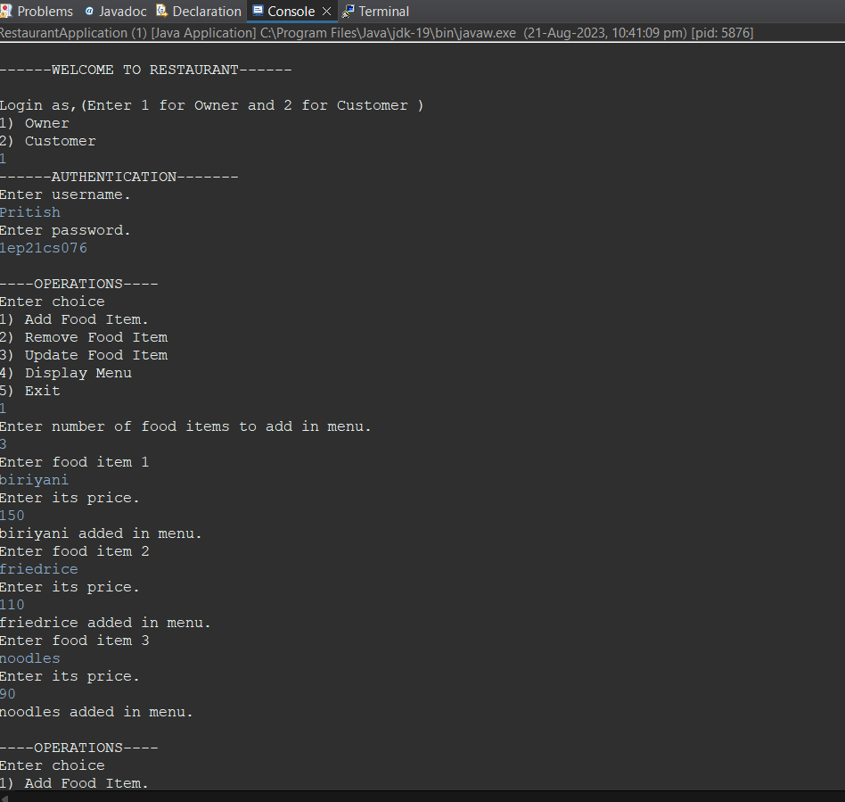

Figure 4.2.1 Adding Food Item By The Owner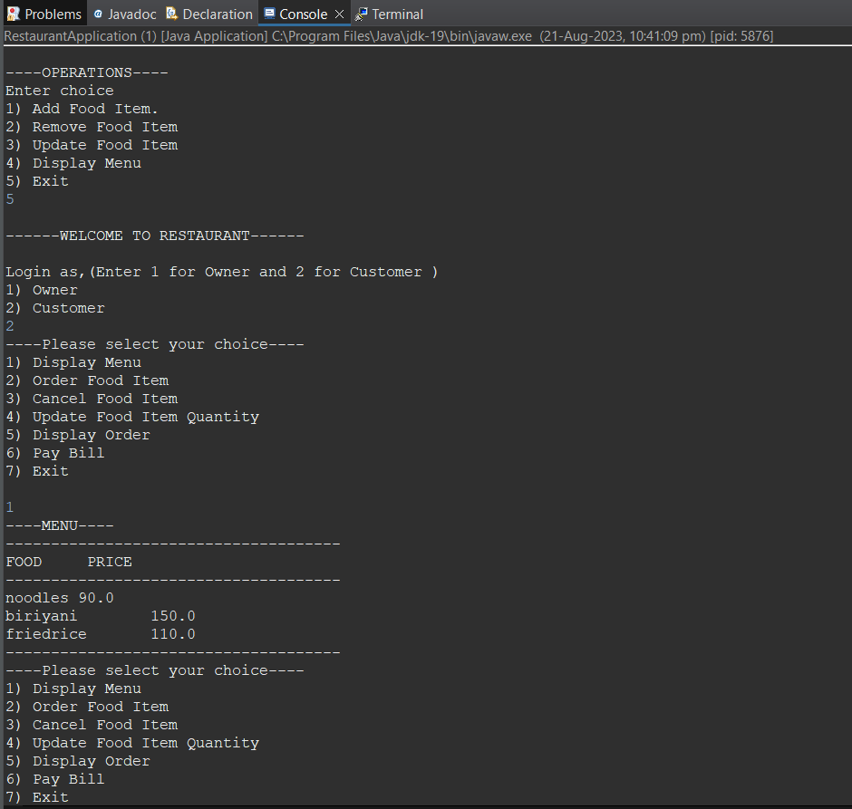

Figure 4.2.2 Displaying Menu and Order Food Item

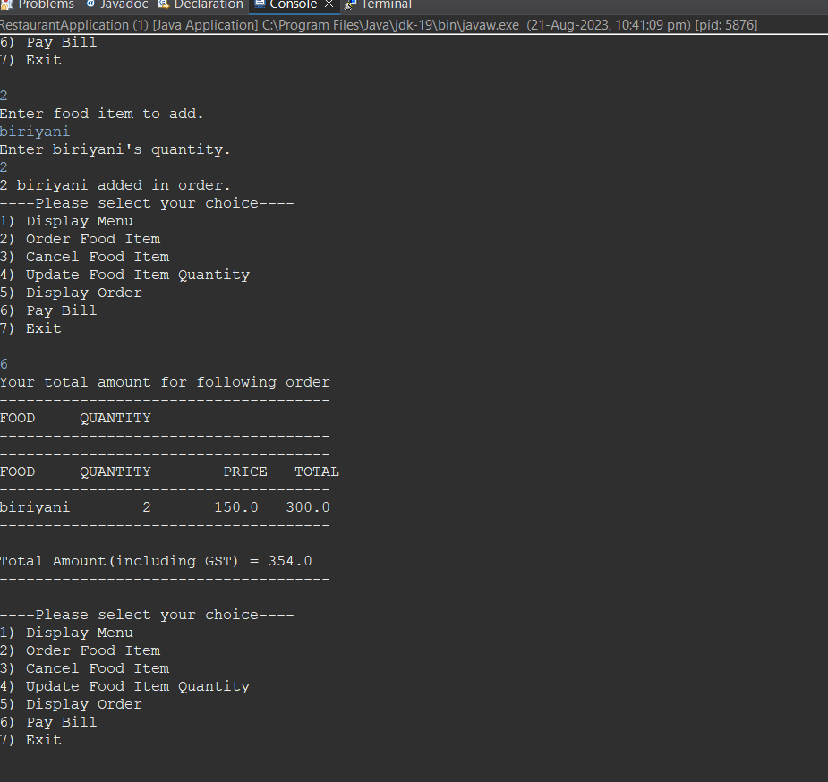

Figure 4.2.3 Generating Bill Including GST

# CHAPTER 5

**CONCLUSION**

Programming is a great skill to develop and learning to think and express yourself logically is a great skill for learning to program.

Programming in Java is itself very interesting in it. The project helped me to develop a thorough understanding of the language i.e. Java , which is an object oriented programming language.

On implementing this project , I learnt the technology Java , servlets and JSP ( which is an extension to servlet ). The aim of this project was to implement a Billing system using Java. It would work with the owner and the customer. The owner could set the menu, price, and update it accordingly and also it could take order from the customer, display menu, show the bill etc.

This will not only help to increase the typing speed of the user but also will also allow them to focus on the words and characters which they have typed i.e., how much accurate they are.

When it comes to Java, logic is the most important thing and this project is all about logic and mathematical formulas. The program in the given project seems to be very realistic.

As part of the project, we worked on different modules of company projects and demonstrated good skills in Java, J2EE, Servlets and JDBC.

We also prepared a report highlighting its flaws by understanding the design briefs and client Specifications that were provided in the Proposal.

**Future Enhancement**

As the current system is a file based one, management of the hotel has to put much effort on securing those files. They can be easily get damaged by a fire, insects or even by a natural disaster like tsunami. Keeping files takes much time and wastes much precious man hours.

Although we can't trust the accuracy of calculations done by manually, it's not a surprise of encountering problems. If we want to check for a previous room record or a reservation detail, management will be in a great problem. It's I tough and time taking process to search for a to implement will be covering all the basic processes done in the Hotel. It would handle Guest details, Reservation details, Inventory management details, Room service details, staff management details and room types.

# REFERENCES

1. Balagurusamy, E. (2007). Programming with JAVA: A Primer, 3rd edition. New Delhi: Tata McGraw-Hill.
2. “Head First Servlets and JSP: Passing the Sun Certified Web Component Developer Exam “, by Bryan Basham (Author), Kathy Sierra (Author), Bert Bates (Author), O'Reilly Media; Second Edition edition (April 1, 2008).
3. Arnold, Ken, James Gosling and David Holmes (2005). The Java Programming Language, 3rd edition. NJ: Prentice Hall.
4. A Programmer's Guide to Java SCJP Certification: A Comprehensive Primer (3rd Edition), Addison-Wesley Professional; 3 edition (December 29, 2008).
5. A Programmer's Guide to Java SCJP Certification: A Comprehensive Primer (3rd Edition), Addison-Wesley Professional; 3 edition (December 29, 2008).
6. “Java The Complete Reference, 8th Edition”, McGraw-Hill Osborne Media; 8 edition (June 22, 2011).